2024 scheduled elections – AEA customisable templates for parish elections in England

We have designed this nominations template to save you time and help candidates complete their nomination forms correctly first time.
It is a guide you can personalise and give to candidates and agents to help them complete their nomination for 2 May 2024.
The annotated notes cover common points that cause confusion or difficulty. Any areas that need local personalisation are in red text.

Annotated nomination papers – Parishes – England
- Process and forms
  - Generally, there are three forms that you must submit to make your nomination valid:
- Nomination form
- Home Address form
- Consent to nomination
You must deliver these forms by hand, and they must be originals -so not copies. Any documents sent by email or fax will not be accepted. It is your responsibility to complete all nomination forms to the deadlines specified in the elections timetable.
  - If you are standing on behalf of a registered political party you will also need to submit:
  - a certificate of authorisation
  - an emblem request form (if they want an emblem on the ballot paper)
These can be delivered by hand or by post but must be originals. Any documents sent by email or fax will not be accepted.
  - Election agents are not appointed at parish elections.
  - If you have any issues with completing your nomination forms, please contact the Election Office [Insert Election Office contact details].
  - It is a good idea to have your nomination paperwork informally checked by the elections office before you formally submit it. [Insert where and how informal check can take place]. This can allow you to make corrections or complete new nomination forms if there are any mistakes.
  - Once your nomination is formally submitted you cannot amend any details. But if you change your mind and no longer want to stand for election, you can withdraw your nomination until 4pm on 5 April 2024.

2 Further Information

Other useful guidance sources
Guidance for Candidates at Parish council elections in England
The Local Elections (Parish and Communities) (England and Wales) Rules 2006

- Annotated forms
These annotated forms cover areas of common confusion or difficulty for you to refer to as you complete your nomination paper.
Notes have been added to draw attention to areas where mistakes are often made, or where you are likely to have questions.

Form 1a – Nomination paper (header)

If the parish has been divided into wards, the ward in which you are standing should be added here.

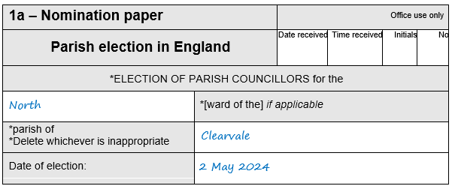
If it has not been pre-printed; the date of the election should be added here.
The name of the parish council should be added here.
E.g., if you are standing for a ward in Clearvale Parish Council, ‘Clearvale’ should be added here.
If you have put the council’s name in full this would not invalidate the nomination.

Form 1a – Nomination paper (Candidate’s details)
The Candidate’s details section must be completed in full before any electors sign the nomination paper

If you are commonly known by a different name to your actual name, you should enter it here. Or, if you use one or more of your names given on your nomination paper in a different manner (e.g. if you are known by your middle name), you should enter it here.
The commonly used name will then appear on the ballot paper and the Statement of Persons Nominated instead of your actual name.
It is important to read Electoral Commission Guidance if a commonly used name is used.

It is not vital that this is completed
Titles will not appear on the ballot paper or other notices

Full names must be added here – no initials.
Prefixes like Sir or suffixes like Snr must not be used.

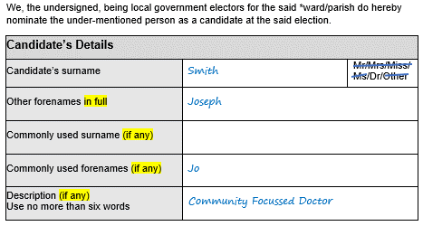
The description may be left blank.

OR you could use the description ‘Independent’.

OR you can use a description of 6 words or less which identifies you and is unlikely to associate you with a political party. Examples include ‘Farmer’, ‘Baker in the High Street’, or ‘member of village action team’, etc;

OR - for political party candidates, you will need to enter the registered party name or description as authorised by the party. This must be as registered with the Electoral Commission, and must match EXACTLY with the description authorised on Form 2 – the Certificate of Authorisation.

It is important to read Electoral Commission Guidance if a description is used.

Form 1a – Nomination paper (subscribers)

You should include the polling district reference and elector number from the register in force when the Notice of Election is published.

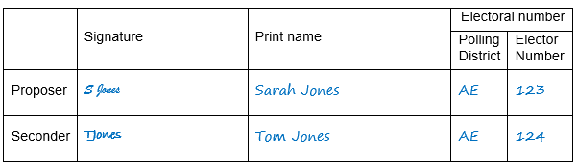
The form must be signed by registered electors. You must have a proposer and seconder from the parish, or if the parish is warded, from the relevant parish ward.
If the Notice of Election has been published earlier than 26 March 2024, we can help you with elector numbers if you tell us the full name and address of the subscriber. Contact us at [INSERT CONTACT DETAILS].
Each subscriber must sign the nomination form in the signature column. Their name must be printed too, preferably in capitals and does not have to exactly match the name printed in the electoral register.
An elector must not sign more nomination papers than there are vacancies in the ward/parish. If subscribers sign more nomination papers than there are vacancies, their signature will only be valid on the first papers delivered to the Returning Officer.
For further information see the Electoral Commission Guidance.

Form 1b – Home address form (header)

If the parish has been divided into wards, the name of the ward you are standing in should be added here.

This section should be completed by election staff when the form is formally submitted.

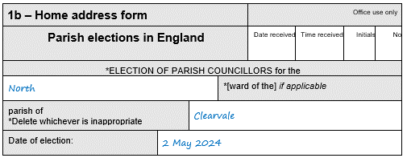
If it has not been pre-printed; the date of the election should be added here.
The name of the parish council should be given here.
E.g., if you are standing for a ward in Clearvale Parish Council, ‘Clearvale’ should be added here.

Form 1b – Home address form (Part 1)
Your home address must be given here:
- in full and without any abbreviations
- it must be your current home address
- it must not be a business address (unless you run a business from your home)
For further information see the EC guidance.

All candidates must complete Part 1 of Form 1b

This should be your actual full name rather than any commonly used name.

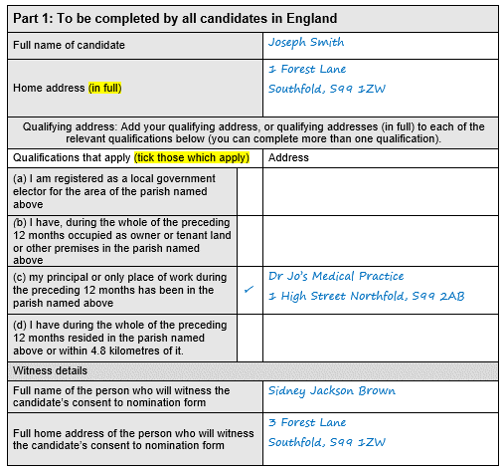
A full address should be written next to each of the qualification that applies to you.
If relevant, a different address may be used for each qualification.
At least one must match the information given on Form 1c.

There are no restrictions on who can be a witness, but the same person will need to witness Form 1c.

Form 1b – Home address form (Part 2)
Candidates who do not want their home address printed on the ballot paper must complete and sign Part 2 of Form 1b.
Part 2 should be submitted whether it is completed or not.

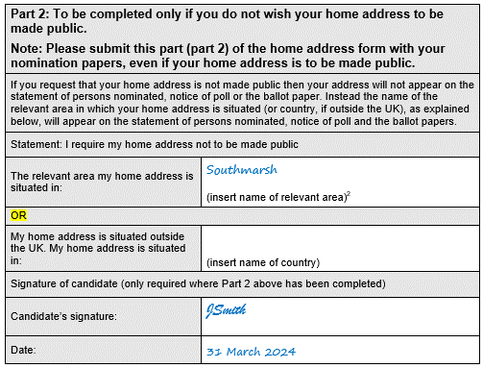
The relevant area is the county/district/London borough your home address is in.
For example, if your home address is in the [INSERT FULL COUNCIL NAME] area, the name of the relevant area is ‘[INSERT COUNCIL NAME]’.
The parish or parish ward should not be given here.
For further information see Electoral Commission Guidance.
If either of the two boxes above have been completed the form must be signed and dated.

Form 1c – Consent to nomination
The entire form must be submitted.

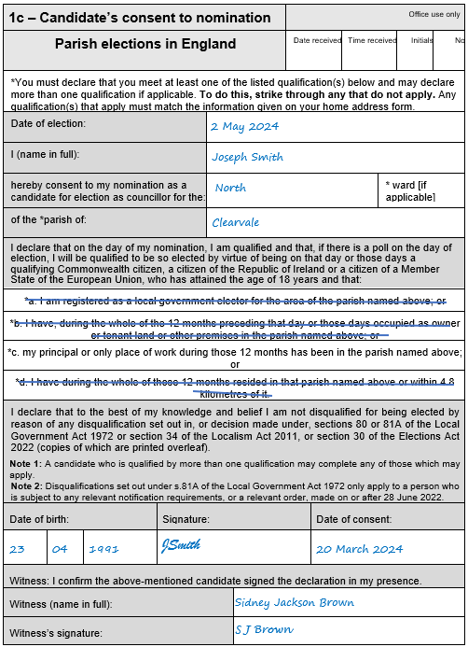
This should be your actual full name (rather than commonly used name) as given in Form 1a.

You must sign here, and the date should not be earlier than 5 March 2024.
You must strike through any qualification that does not apply, leaving at least one not struck through.
The qualifications which apply must match the information given in Part 1 of Form 1b.

You must be 18 or over on the date of submitting the nomination paper.

This must be the same person who witnessed Part 1 of Form 1b.

Form 2 – Certificate of authorisation
For party candidates only

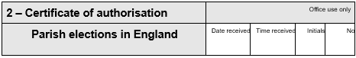
If you are authorised to use a specific registered description or the party name, it should be written here. Must match description on Form 1a.
Or, if you are authorised to choose from a range of registered descriptions or party names, it should say ‘any registered description or the party’s name as registered with the Electoral Commission’.
Check the Electoral Commission website for descriptions.

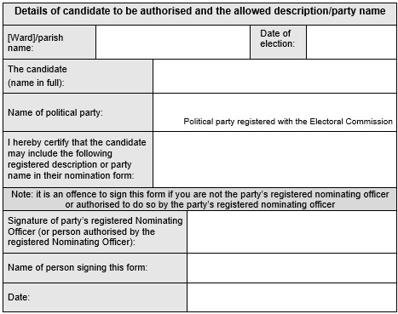
Must be signed by the party’s Nominating Officer or someone authorised by them.

Registered party names and descriptions can be found on the Electoral Commission website.
Search the registration details of the party and
click for more details to view the descriptions
available to choose from.

Form 3 – Emblem request form
For party candidates only

(To request an emblem as registered with the EC)
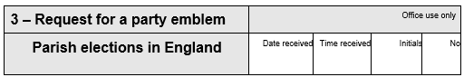
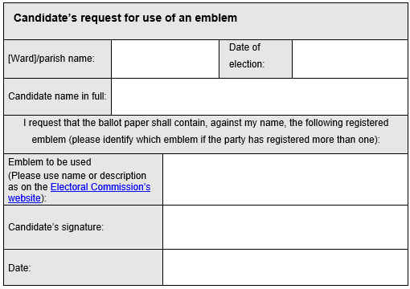
This should be the name as registered with the EC e.g., “Emblem for use in England” or “Emblem ID 999”.

Must be signed by you.

Emblems can be found on the Electoral Commission website by searching the registration details for the party and clicking for more details to view the emblems.

Appendix A – Example of correctly completed nomination

